What is Amazon S3?

1.Amazon S3 is an object storage service that offers industry-leading scalability, data availability, security, and performance. It is an Object storage built to store and retrieve any amount of data from anywhere.

2.Store and protect any amount of data for a range of use cases, such as data lakes, websites, cloud-native applications, backups, archive, machine learning, and analytics.

3.Amazon S3 is designed for 99.999999999% (11 9's) of durability, and stores data for millions of customers all around the world..

## Use Cases

##### **Build a Data Lake**

Run big data analytics, artificial intelligence (AI), machine learning (ML), and high-performance computing (HPC) applications to unlock data insights.

##### **Run Cloud-Native Applications**

Build fast, powerful mobile and web-based cloud-native apps that scale automatically in a highly available configuration.

##### **Backup and Restore Critical Data**

Meet Recovery Time Objectives (RTO), Recovery Point Objectives (RPO), and compliance requirements with S3’s robust replication features.

##### **Archive Data at Low Cost**

Move on-premises archives to the low-cost S3 Glacier and S3 Glacier Deep Archive storage classes to eliminate operational complexities.

**S3 features** include capabilities to append metadata tags to objects, move and store data across the S3 Storage Classes, configure and enforce data access controls, secure data against unauthorized users, run big data analytics, and monitor data at the object, bucket levels, and view storage usage and activity trends across your organization.

PRODUCT-----Amazon s3

DESCRIPTION----

Object storage service that offers industry-leading scalability, data availability, security, and performance.

FREE TIER OFFER DETAILS

12 MONTHS FREE  
  
5 GB in the S3 Standard storage class  
  
20,000 Get Requests  
  
2,000 Put, Copy, Post, or List Requests

PRODUCT PRICING….Amazon S3 Pricing…. With S3, there are no minimum fees. You only pay for what you use. Prices are based on the location of your S3 bucket.

**Common tasks**

[Get started with S3](https://docs.aws.amazon.com/console/s3/gs)

[Create a bucket](https://docs.aws.amazon.com/console/s3/task-create-bucket)

[Upload an object](https://docs.aws.amazon.com/console/s3/task-upload-object)

[Download an object](https://docs.aws.amazon.com/console/s3/task-download-object)

[Host a static website](https://docs.aws.amazon.com/console/s3/task-host-website)

**In Brief:**

Customers of all sizes and industries can store and protect any amount of data for virtually any use case, such as data lakes, cloud-native applications, and mobile apps. With cost-effective storage classes and easy-to-use management features, you can optimize costs, organize data, and configure fine-tuned access controls to meet specific business, organizational, and compliance requirements.

Every object in S3 is stored in a bucket. To upload files and folders to S3, you’ll need to create a bucket where the objects will be stored

**AWS Compute Services:-**

1. EC2
2. EC2 Immage Builder
3. Lambda
4. Elastic BeanStalk
5. Serverless Application Repository
6. AWS App Runner
7. AWS Outposts
8. Batch
9. Lightsail
10. AWS Simspace Weaver

**What is EC2 in AWS used for?**

Amazon Elastic Compute Cloud (Amazon EC2) is a web service that provides secure, resizable compute capacity in the cloud. It is designed to make web-scale cloud computing easier for developers. Amazon EC2's simple web service interface allows you to obtain and configure capacity with minimal friction.

Here are different types of EC2 Instances: General Purpose Instances. Compute Optimized Instances. Memory-Optimized Instances.

**When should you use EC2?**

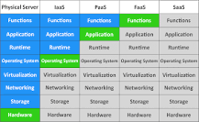

Using AWS EC2 is good for running high-performance applications, long-running applications, and the applications that must not have a delay at the start time. If you use AWS EC2 instances, don't forget to back them up to avoid losing your data

**What are two benefits of Amazon EC2?**

* Elastic Web-Scale Computing. Amazon EC2 enables you to increase or decrease capacity within minutes, not hours or days. ...
* Completely Controlled. You have complete control of your instances including root access and the ability to interact with them as you would any machine. ...
* Flexible Cloud Hosting Services.

**What are the key features of EC2?**

Amazon EC2 provides the broadest and deepest instance choice to match your workload's needs. General purpose, compute optimized, memory optimized, storage optimized, and accelerated computing instance types are available that provide the optimal compute, memory, storage, and networking balance for your workloads.

**The advantages/benefits of EC2 are listed below:**

* Reliability. Amazon EC2 provides 99.9% availability in each Amazon EC2 region. ...
* Safety. Amazon collaborates with Amazon VPC to provide secure networking and compute resources. ...
* Adaptability. ...
* Cost-cutting. ...
* Full-Service Computing Solution. ...
* Elastic Web-Scale Computing.

### **E EC2 Image Builder :-**

### **What is** EC2 Image Builder allows you to easily validate your images for functionality, compatibility, and security compliance with AWS-provided tests and your own tests before using them in production. Doing so reduces errors found in images normally caused by insufficient testing. **Buil**

**What is Imagebuilder?**

An image builder is a tool used in system administration to create a copy—an exact image—of a virtual system or configuration (such as an operating system, server, virtual machine [VM], container, etc.)

**What is component in EC2 image builder?**

### Components are the building blocks that are consumed by an image recipe or a container recipe. For example, packages for installation, security hardening steps, and tests. The selected base image and components make up an image recipe.

**How does EC2 image builder work?**

EC2 Image Builder is a fully managed AWS service that helps you to automate the creation, management, and deployment of customized, secure, and up-to-date server images. You can use the AWS Management Console, AWS Command Line Interface, or APIs to create custom images in your AWS account.

**What are images in EC2?**

An Amazon Machine Image (AMI) is a master image for the creation of virtual servers -- known as EC2 instances -- in the Amazon Web Services (AWS) environment. The machine images are like templates that are configured with an operating system and other software that determine the user's operating environment.

**What is Lambda in AWS cloud?**

AWS Lambda is a serverless, event-driven compute service that lets you run code for virtually any type of application or backend service without provisioning or managing servers. You can trigger Lambda from over 200 AWS services and software as a service (SaaS) application, and only pay for what you use.

**Lambda**

**Why is it called Lambda in AWS?**

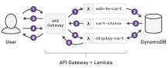

Lambda is named after functions from lambda calculus and programming. Those functions act as a good analogy for the service. In Lambda, you write a function and connect it to other services, such as API Gateway, S3, Kinesis, EC2, etc., in order to compose part of an application.

**What are the 3 components of AWS Lambda?**

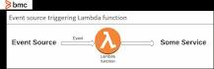

**Three components comprise AWS Lambda:**

* A function. This is the actual code that performs the task.
* A configuration. This specifies how your function is executed.
* An event source (optional). This is the event that triggers the function. You can trigger with several AWS services or a third-party service.

**What is an example of AWS Lambda?**

* 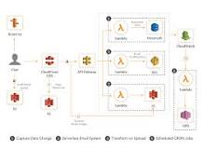
* Another example, you can use AWS Lambda to notify SNS for multiple use cases. Suppose you want to send out an email whenever new books are added to the library. For this, whenever new books are added to the database, an AWS Lambda function will trigger which will notify SNS.

**When should I use Lambda?**

Use a Lambda when you need to access several services or do custom processing. As data flows through services, you use Lambdas to run custom code on that data stream. This is useful in a Kinesis Pipeline that's receiving data from things like IoT devices.

**Elastic BeanStalk**

**What does AWS Elastic Beanstalk do?**

Elastic Beanstalk is a service for deploying and scaling web applications and services. Upload your code and Elastic Beanstalk automatically handles the deployment—from capacity provisioning, load balancing, and auto scaling to application health monitoring.

**What is example of Elastic Beanstalk?**



AWS Elastic Beanstalk allows you to select the configuration of the AWS services that you have used with your application. For example, consider Amazon EC2, you can change the AWS EC2 instance types which is optimal for your application.

**Why is it called Elastic Beanstalk?**

Name. The name "Elastic beanstalk" is a reference to the beanstalk that grew all the way up to the clouds in the fairy tale Jack and the Beanstalk.

**When should I use Elastic Beanstalk?**

AWS Elastic Beanstalk makes it even easier for developers to quickly deploy and manage applications in the AWS Cloud. Developers simply upload their application, and Elastic Beanstalk automatically handles the deployment details of capacity provisioning, load balancing, auto-scaling, and application health monitoring.

**ServerLess Application Repository**

**What is AWS serverless repo?**

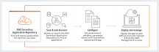

The AWS Serverless Application Repository is a managed repository for serverless applications. It enables teams, organizations, and individual developers to store and share reusable applications, and easily assemble and deploy serverless architectures in powerful new ways. What is meant by serverless application?

Serverless is a cloud-native development model that allows developers to build and run applications without having to manage servers. There are still servers in serverless, but they are abstracted away from app development

**What is use of serverless in AWS?**

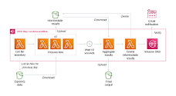

Serverless on AWS. AWS offers technologies for running code, managing data, and integrating applications, all without managing servers. Serverless technologies feature automatic scaling, built-in high availability, and a pay-for-use billing model to increase agility and optimize costs.

**What are the different types of serverless applications?**

**Types of Serverless Systems**

* Quick Intro. Originally, serverless started as Function-as-a-Service (Faas), only for computing purposes. ...
* Compute. Developers can deploy code and run it on-demand or on-schedule. ...
* Queue/Message Buffer. ...
* Stream Processing. ...
* Event Bus. ...
* Database. ...
* Blob Storage. ...
* API Endpoints.

**What are the 4 pillars of serverless?**

These pillars are Operational Excellence (OPS), Security (SEC), Reliability (REL), Performance Efficiency (PERF), and Cost Optimization (COST).

**What is serverless model in AWS?**

The AWS Serverless Application Model (SAM) is an open-source framework for building serverless applications. It provides shorthand syntax to express functions, APIs, databases, and event source mappings. With just a few lines per resource, you can define the application you want and model it using YAML.

**AWS App Runner**

AWS App Runner is a fully managed container application service that lets you build, deploy, and run containerized web applications and API services without prior infrastructure or container experience.

**How does App Runner work?**

App Runner automatically builds and deploys your application, scales the number of containers up or down to meet your needs, and load balances traffic to provide high levels of reliability and availability. Developers can push their changes, and the changes will be automatically deployed into a new container.

**What is the alternative to AWS App Runner?**

The three main AWS alternatives to App Runner are Elastic Container Service (ECS), Lambda when used with container images and EC2 or Lightsail

**How do I deploy AWS App Runner?**

**To deploy using the App Runner console**

1. Open the App Runner console , and in the Regions list, select your AWS Region.
2. In the navigation pane, choose Services, and then choose your App Runner service. ...
3. Choose Deploy. ...
4. Wait for the deployment to end….

**AWS Outposts**

AWS Outposts is a family of fully managed solutions delivering AWS infrastructure and services to virtually any on-premises or edge location for a truly consistent hybrid experience.

**Who does AWS deliver outpost to?**

AWS will deliver Outposts servers directly to you, and you can either have your onsite personnel install them or an AWS preferred third-party contractor. After the Outposts servers are connected to your network, AWS will remotely provision compute and storage resources so you can start launching applications.

**How big is an AWS outpost?**

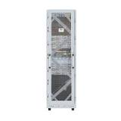

AWS Outposts rack is delivered as an industry-standard 42U rack. The Outposts rack is 80 inches (203.2cm) tall, 24 inches (60.96cm) wide, and 48 inches (121.92cm) deep. Inside we have hosts, switches, a network patch panel, a power shelf, and blank panels.

**What is the benefit of AWS outpost?**

By providing local access to AWS managed infrastructure, AWS Outposts enables customers to build and run applications on premises using the same programming interfaces as in AWS Regions, while using local compute and storage resources for lower latency and local data processing needs.

**What are the limitations of AWS outposts?**

You can have 100 Outposts sites in each Region of your AWS account. AWS Outposts includes hardware and virtual resources, known as Outposts. This quota limits your Outpost virtual resources. You can have 10 Outposts in each Outpost site.

**What does outpost stand for?**

: an outlying or frontier settlement. : an outlying branch or position of a main organization or group.

**Batch**

**What is use of AWS Batch?**

AWS Batch handles job execution and compute resource management, allowing you to focus on developing applications or analyzing results instead of setting up and managing infrastructure. If you are considering running or moving batch workloads to AWS, you should consider using AWS Batch.

**What is AWS Batch process?**

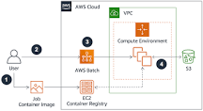

AWS Batch is a fully managed service that enables you to run large-scale compute workloads in the cloud without provisioning resources or managing schedulers. AWS Batch enables developers, scientists, and engineers to easily and efficiently run hundreds of thousands of batch computing jobs on AWS.

**Who uses AWS Batch?**

AWS Batch helps you to run batch computing workloads on the AWS Cloud. Batch computing is a common way for developers, scientists, and engineers to access large amounts of compute resources.

**What does batch do?**

A batch file is a script file that stores commands to be executed in a serial order. It helps automate routine tasks without requiring user input or intervention. Some common applications of batch files include loading programs, running multiple processes or performing repetitive actions in a sequence in the system.

**What are three examples of batch?**

Some examples of batch processes are beverage processing, biotech products manufacturing, dairy processing, food processing, pharmaceutical formulations and soap manufacturing.

**What is a real life example of batch operating system?**

Examples of Batch based Operating System: Payroll System, Bank Statements etc. Each task is given some time to execute, so that all the tasks work smoothly. Each user gets a time time slot on the CPU. These systems are also known as Multitasking Systems.

**What is batch processing also known as?**

Batch processing is also known as serial,sequential and off line processing. Batch Processing – This is one of the widely used type of data processing which is also known as serial/sequential, tacked/queued of offline processing.

**LightSail**

**What is Amazon Lightsail?** Amazon Lightsail is a virtual private server (VPS) provider and is the easiest way to get started with AWS for developers, small businesses, students, and other users who need a solution to build and host their applications on cloud.

**AWS Simspace Weaver**

**What is SimSpace Weaver?**

AWS SimSpace Weaver is a service that you can use to build and run large-scale spatial simulations in the AWS Cloud. For example, you can create crowd simulations, large real-world environments, and immersive and interactive experiences.

# **How many environments should we have in the software development lifecycle?**

# Development, test, performance, staging, canary, production…

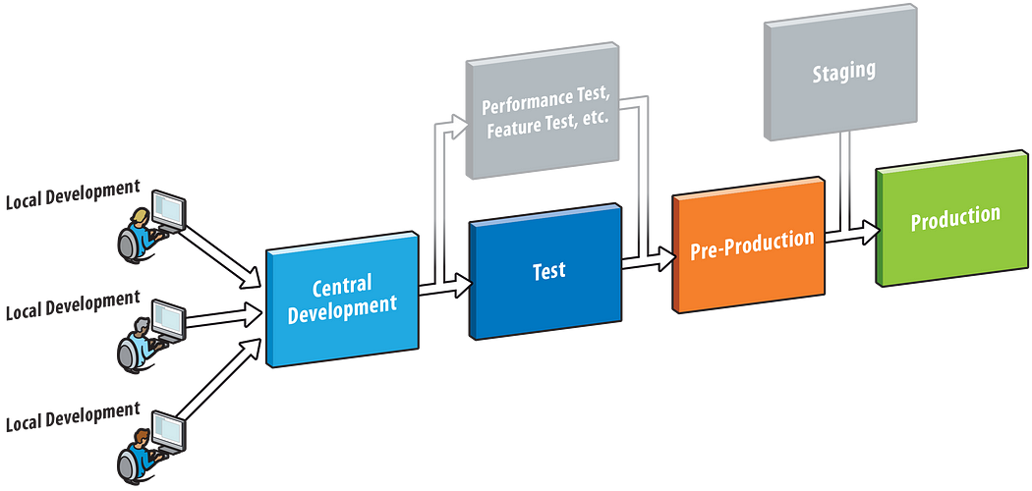

I have a theory (and some experience) that having fewer environments in the software ecosystem is better than having more of them.

It’s a common practice in many software projects to have:

* The development environment — also known as the developer’s computer
* The development integrated environment — a remote environment used by developers to have their code integrated so that they can check if they broke the code of someone else, or if someone else broke their code
* The test environments — environments used for manual and/or automated tests
* The staging environment — used for acceptance testing before pushing new code to production
* The canary environment — a special kind of environment used to test new features with a small set of users (commonly used to test things internally before reaching the broader audience)
* The production environment — the environment that our users really use

Some might argue that having all these environments is a good thing. I say it’s not.

The more environments you have, the more problems you have to deal with.

### **t to store and retrieve any amount of data from anywhere**